### Stevens Institute of Technology



TrainX Architects

IoT Hug the Rail

v.2.0

Bonnie Nguyen, Roma Razdan, Matthew Viafora, and Michael Zylka

Software Development Process

Professor Peyrovian

### **Section 1:**

#### **Introduction:**

Using the internet of things, our group will devise a method to allow decisions to be made locally in absence or failure of cellular and wifi. This will be implemented into the Train System (Hug the Rail) as a means of making it safer, less costly, and more efficient.

Our team consists of several smart, problem-solving, communicative individuals who strive to create an innovative design. Mike is a creative individual who will take the proper initiative to learn about the best possible solution for our project. Matt is a member who is very detail oriented and will ensure that the work we produce is truly working to create a safer, less costly, and more efficient solution. Bonnie is someone who is very task oriented and will help the overall flow of the project move smoothly, and Roma is someone who is people-oriented and will ensure that this model will be user-friendly and meet all the stakeholders’ criteria.

Together this team, otherwise known as TrainX Architects, will work together to revolutionize the future of railroads as we know it today. We are looking to innovate the current solution, as well as looking for new ways to expedite the user’s experience while maintaining a connection to our design.

Our personal perspective on this project is to produce a system (engine) that informs the user of the train about current conditions, then to have an interface that allows the conductor to manipulate the train speeds according to that information. While this is rather general, we will work to pose a more detailed solution to our problem as we move through the planning process that this project will entail.

We see ourselves working to continue planning, then soon to begin modeling, construction, and deployment. After that we will reevaluate and communicate with our stakeholders and our group to ensure we are meeting their expectations. We have yet to create deliverables where we set due dates for each aspect of our project but we look forward to making more progress in reaching our goals.

**Timeline:** 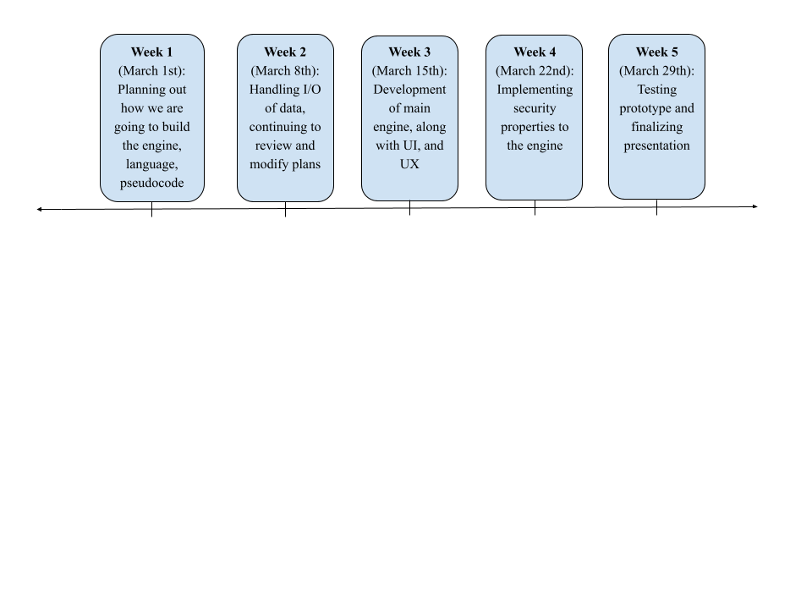

**Model:**

(Spiral Process Model)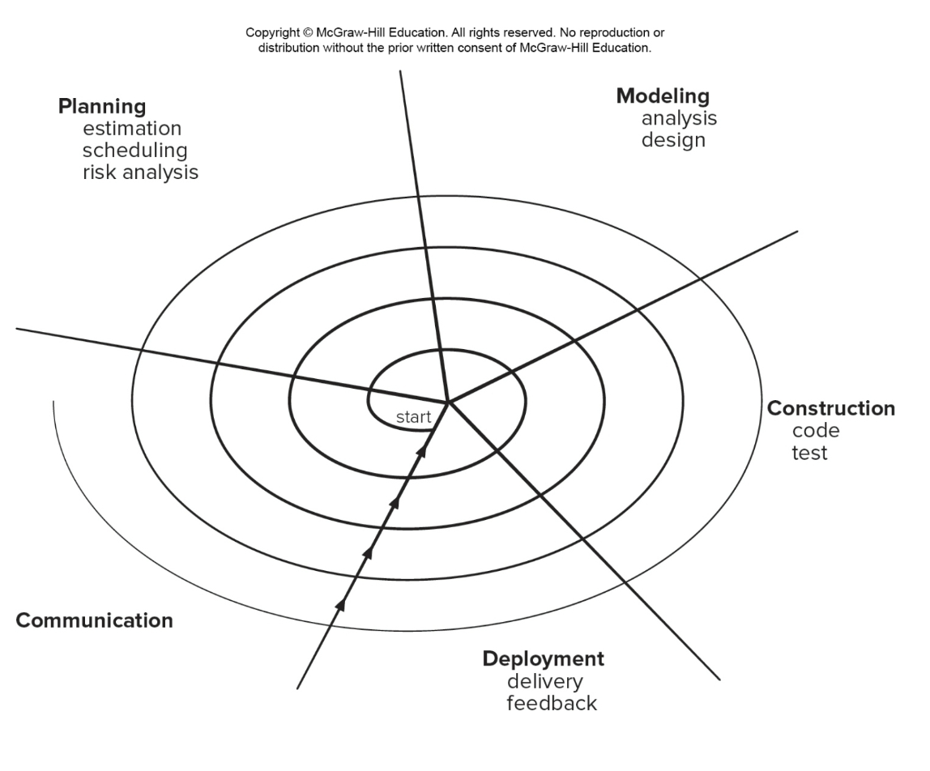

|  |  |
| --- | --- |
| Pros | Cons |
| * Continuous customer involvement * Development risks are managed * Suitable for large, complex projects * Allows to change * Works well for extensible products | * Risk analysis failures can doom the project * Project may be hard to manage * Requires an expect development team |

### **Section 2:**

**Problem Statement:** The train operation depends on live data received from the Central Operation Center Servers via WiFi/Cellular network. We need to be able to operate the train when we lose WiFi/Celluar network. We need to develop a system to allow us to continue the trip safely based on local data that we can collect. We assume GPS data is available.

**System Overview**

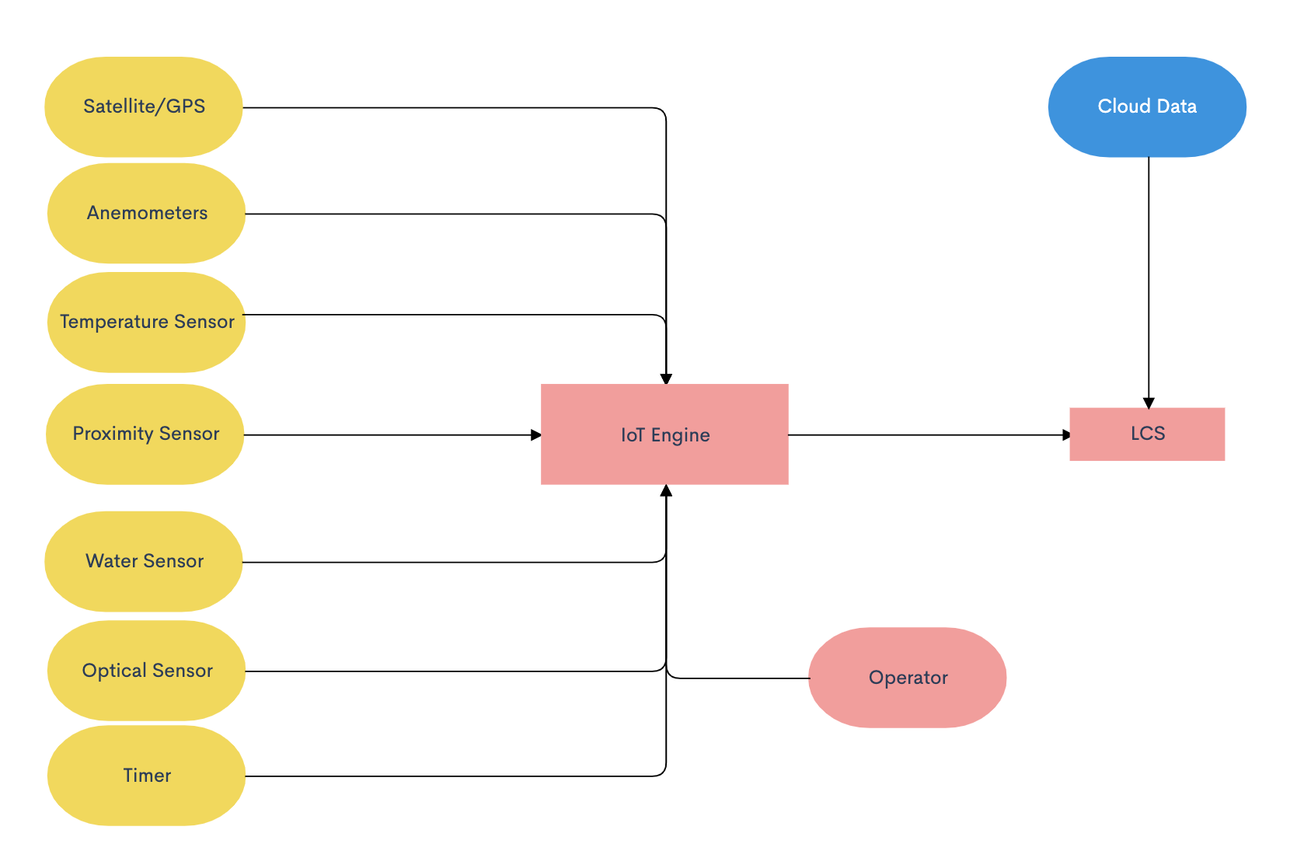

* Using installed sensors and computers outlined in the flowchart above, the IoT engine will take in different inputs from the data collected by the external sensors.
* The operator also has input into the IoT engine as they have power to adjust any part of the IoT engine including the speed of the train. The operator may have access to information that is not collected by the external sensors via radio, visual, etc.
* The IoT engine utilizes the data collected from these different sensors and/or if the operator influences anything and dynamically adjusts the throttle to brake or speed up appropriately.
* The LCS also has access to cloud data previously collected before the train lost connection, any previous data of value including arrival and departure times can be used until connection is regained.

**Data Required**

* Weather condition (such as snow, ice, rain, and wind)
* Hazards on the track both front and back
* Gate opening and closing times
* Arrival and departure times

**Technology Required**

* Temperature
  + Temperature sensor will measure the temperature outside and work with the optical sensor to determine an ideal speed for the train while not connected.
* Optical sensor
  + Ensure that the train does not start “slipping” on tracks and the locomotive is kept in control the entire time.
* Proximity sensor
  + In order to detect hazards on the railway both in front and in back of the train, there will be proximity sensors placed on the train that will work with IoT in order to determine if a change in the locomotive speed should occur.
* Water Sensor
  + Water sensors should be placed in strategic locations on the train in order to properly monitor weather conditions outside. Depending on the severity of the weather conditions, the water sensor should interface with the IoT to properly determine the ideal travel speed for the train.
* Timer
  + In order to properly arrive at gates on time and be prepared to stop in case of a scheduled downed gate or terminal, all arrival and departure times should be downloaded before losing connection. The IoT will work with this pre-downloaded data in order to determine the proper speed to arrive on time and not too early or too late.
* Anemometers
  + In case of harsh weather conditions, the locomotive should be prepared to travel with caution. An anemometer to measure wind speeds should be programmed to collaborate with the IoT architecture to determine if the train should travel at a cautious speed.
* Satellite Technology/GPS
  + Rely on GPS technology to determine the current position and direction of the train. Data can be drawn from the GPS to ensure the train stays on its intended route and not conflict with other trains in the area.
  + GPS also provides data on the speed of the train to interface with the other sensors and IoT in order to accommodate for outside conditions.

### **Section 3:**

**Requirements**

**3.1 Non-Functional Requirements**

3.1.1: IoT HTR shall only be accessed via Operator ID and Password.

* We have to make sure that our information can only be assessed by a secure ID and password to ensure that we are to have complete control over our project.

3.1.2:IoT HTR Admin shall have secured (Admin ID/Pwd) to all sensors and equipment.

* Additionally, we have to ensure that our ID and password also are incorporated into the sensors and equipment to ensure the same security for our devices. This will allow our whole system to work without a fail rate.

3.1.3: IoT HTR Network shall be secured by LoRaWan protocol

* We will use a lower power wide area connection which will be wireless which provides single hop links between our server and the engine allowing for secure connections.

3.1.4: IoT HTR shall process an event within 0.5 seconds.

* Between 0.1 second and 1 second is a comfortable range in system response time where the user feels as though the system is responding without interrupting flow of thought, so in order to maintain the usability of the product, the sensors as well as the system itself must provide 0.5 seconds or less of processing time.

3.1.5: IoT HTR shall process 1000 events per second without degrading service.

* The scalability of the system must still process an event within 0.5 even when processing 1000 events/second, including responding to the user and working simultaneously with other processes in the system over a WiFi/LTE connection.

3.1.6: IoT HTR shall operate with no failure 99.99% of the time.

* In order to ensure the safety of the operators and reliability of the IoT engine, extensive testing will be required until there are little to no failures whatsoever.
* The reliability of the IoT engine is mission critical to the safety and security of TrainX, its customers and the environment traveled.

**3.2 Functional Requirements**

3.2.1 Detect standing objects on the path of the train with distance, speed and suggestion to Conductor on braking or decreasing/increasing speed

* Proximity sensors shall be installed on both the front and rear of the train
* Proximity sensors report constant updates on standing hazards on the track to the IoT Engine
* IoT Engine makes needed calculations to recommend amount of braking required to possibly make an emergency stop

3.2.2 Detect moving objects ahead or behind and their speed, distance, with suggestion of brake, increase/decrease speed

* Proximity sensors report speed of moving objects ahead or behind train to IoT Engine
* IoT Engine makes needed calculations to determine whether and how much to increase or decrease speed

3.2.3 Detect gate crossing open/closed, distance, speed and suggestion of braking, speed increase /decrease

* IoT Engine shall utilize local timers, data, and GPS speed to determine appropriate speed to arrive at gate crossing at scheduled time

3.2.4 Detect wheel slippage, using GPS and wheel RPM, suggest braking or increase/ decrease speed

* Optical sensor and satellite GPS will send data to IoT Engine regarding to train speed and RPM to calculate whether the train is slipping on the tracks
* IoT Engine will suggest braking or increasing speed based on data from sensors

3.2.5 Detect severe weather conditions, suggest braking or increase/decrease speed

* Water sensor, Anemometer and Temperature sensor will send data to IoT Engine every 5 seconds relating to rainfall, wind speeds, and temperature
* IoT Engine will make appreciate calculations to determine if severe weather conditions warrants braking, increasing/decreasing speed

3.2.4 Display Requirements

* The IoT HTR Engine will be able to display the data in its own way they receive to the train operator in an interface.
* The operator and admin will have a terminal based display and interface that will allow them to use the engine.

3.2.5 Operator, and Admin privileges

* Operator: Has access to the polished result of sensor data.
  + Operator will access display via User ID and password
* Admin: Has access to the data received by all the sensors, can enable or disable sensors, create or delete other accounts, and change account privileges
  + Admin will access IoT HTR via Admin ID and password
  + Admin has access to log data, software update and configuration, etc.

**3.3 Hardware & Operating System**

3.3.1: IoT Hardware shall be able to support 10,000 sensors

* The compatibility of the hardware must ensure that all the sensors of the system can co-exist and function/interact properly within the same environment.

3.3.2: The Engine will be able to support up to 5TB of data a day.

* The engine will be able to transport up to 5TB of data a day between all of the sensors and throughout the Network.